**INSTALLATION AND USER MANUAL FOR THE AB-Qi MODULE**

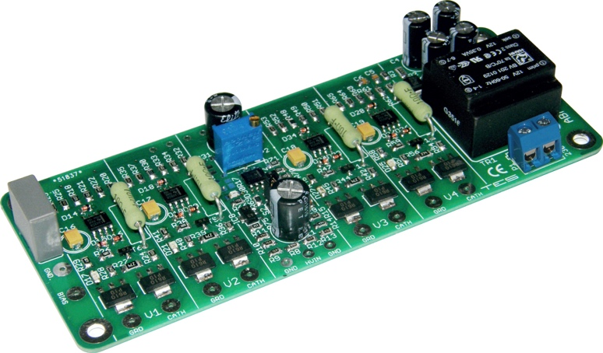

**Introduction:**

This module has been designed to maintain a constant bias voltage through all power output tubes for your tube stereo power amp.

The bias is kept at a constant level on the output tubes, irrespective of the signal level.

**Benefits:**

The advantage of using the AB-Qi module is that it will extend output tube life, in a lot of cases it will also improve the sound and last but not least, you will never have to worry about adjusting the bias again.

* Instead of a pair of output tubes being biased together, now all output tubes are individually biased for greater control and stability
* No need to keep an eye on and/or adjust the bias of the output tubes
* Significant extension of the output tubes life
* Bias is not influenced by the input signal
* Undistorted and improved sound for a great listening experience
* Reduction in hum and noise level of the amp
* No maintenance or additional adjustments are required after the initial setup
* Improved overall operation of the amp due to the reduction in the danger of a tube red plating
* The AB-Qi ensures that bias is kept at the pre-set value (see Initial Setup) even as the tubes age
* The AB-Qi comes with a soft start feature, which slowly brings up bias to each output tube
* The AB-Qi comes with its own 6.3VAC isolation transformer, designed for use in an amp where the filament supply is referenced to ground

**Quick Overview:**

The AB-Qi module has four blue LED’s, one for each output tube, which when lit, indicate that bias is at the correct level and that all is good with each tube.

Should any of these blue LED’s go out or not go on after power up, means that here is an issue with that given output tube and that the tube in question needs to be immediately replaced.

When the amp is powered up, at first a red LED will be on, indicating that there is power to the AB-Qi module. The red LED will go out after about 20s.

After a further delay of between 40-50s, each of the blue LED’s should come on indicating that the bias is now set and stable for each output tube. The amp is now ready to use.

The AB-Qi is suitable for class A, AB and C tube amplifies.

**Presetting the AB-Qi module bias level:**

Before the AB-Qi module can be wired up, you need to preset its bias voltage.

As an example, for EL34 tubes, we recommend a bias voltage of 425mA, for KT88 tubes we recommend 450mV. You will need to consult the tube specifications in order to determine the optimal bias voltage for the tube in your amp.

This bias level is set using the blue colored trimmer on the AB-Qi module.

*We strongly recommend that you preset the* AB-Qi *module before you proceed with installing it into your tube amp!*

The AB-Qi has an isolation transformer for the 6.3VAC supply, so simply connect your amps 6.3VAC filament supply to the two terminals under the transformer.

***Although in the below diagram it shows 230VAC, DO NOT connect mains supply there, ONLY the 6.3VAC filament supply!***

Place your AB-Qi module on a non-conductive surface. Apply power to the AB-Qi module and you should see the red LED on the AB-Qi module light up. This LED will go out after about 20s.

Set your meter to read DC and to the lowest scale, say 1V, 2V or 5V. Put the black meter lead on any **GND** pad on the AB-Qi module and put the red meter lead on the pad next to electrolytic capacitor, see below. Now adjust the blue trimmer until the desired bias level is achieved.

That’s it, you just set the AB-Qi module to the desired bias operating level.

**Example:**  
PP stage 2 x EL34, class AB1, ultra linear:  
To set the bias for an EL34 tube, the recommended anode current for AB1 class is 42.5 mA. We therefore set the bias at 425 mV (0.425 V).

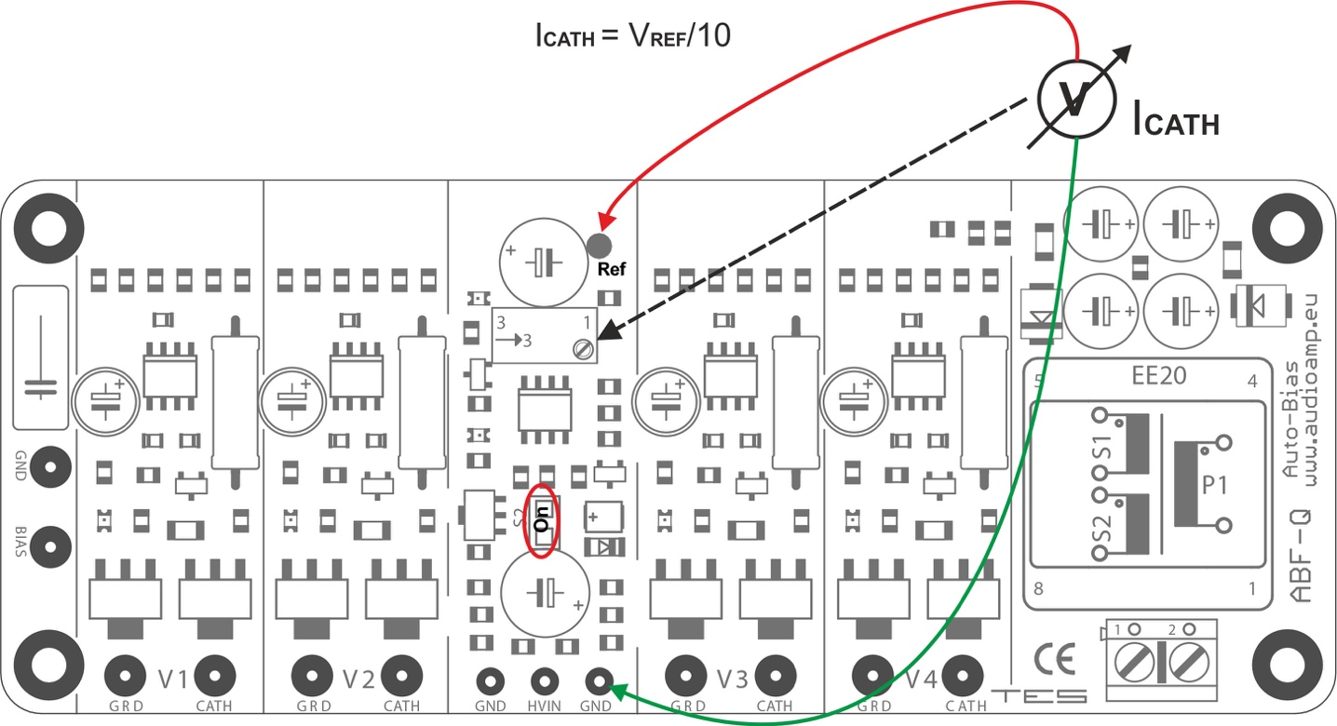

Unplug the power cord, wait for half a minute or so and disconnect the wires from the mains terminals on the AB-Qi module.

***DO NOT EVER readjust the trimmer once the AB-Qi*** ***module is installed and wired up. The whole idea is to set in ONCE and forget!***

**Installing and wiring the AB-Qi** **module into your tube amp:**

Please refer to the drawing below, which shows a typical tube amps connection for your AB-Qi module.

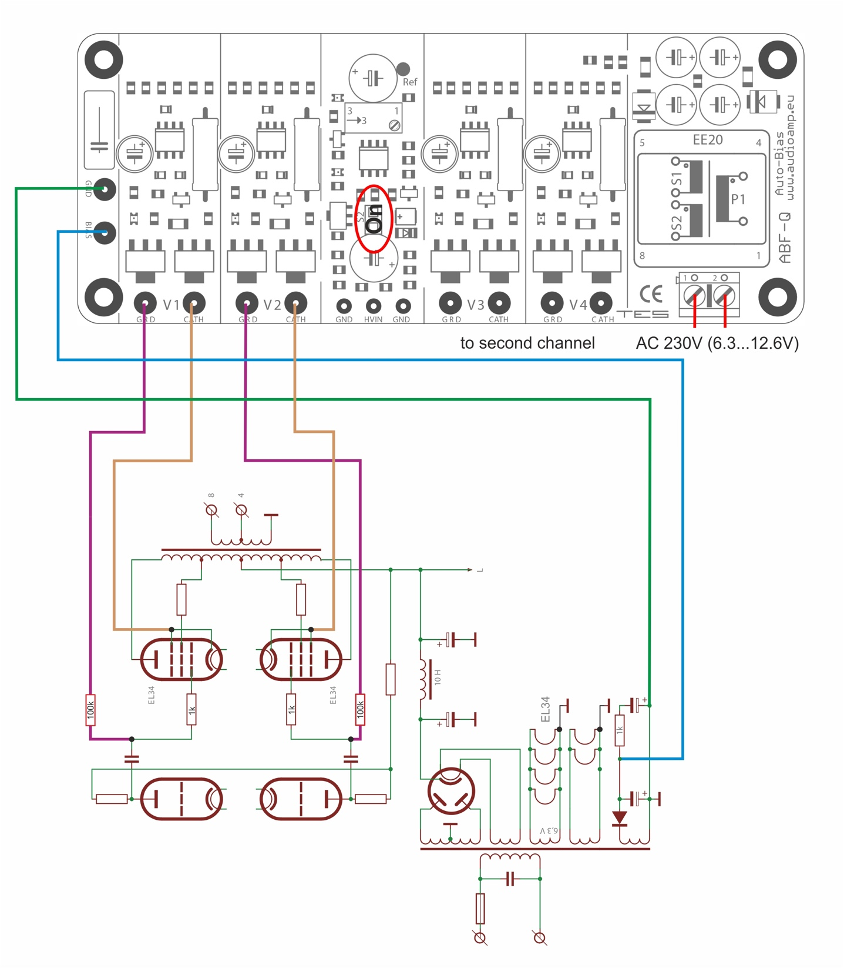

Use the above diagram as a reference to the wiring of the AB-qI module into your amp. Only one channel is shown, the other channel is identical.

* Connect your amps -ve bias supply to the **BIAS** pad on the AB-Qi, shown as a blue wire in the above drawing
* Connect a wire from your amps star ground to the **GND** pad on the AB-Qi, shown as a green wire in the above drawing
* Connect two wires from your amps 6.3VAC filament supply to the two large terminals below the isolation transformer. ***Although in the above diagram it shows 230VAC, DO NOT connect mains supply there, ONLY the 6.3VAC filament supply!***
* Connect each of the four **CATH** pads on the AB-Qi module to the CATHODE of each relevant tube, shown as brown wires in the above drawing. With almost most power tubes, this is pin 8. We also recommend that you connect the cathode of your tube, if it is a pentode, to the Suppressor grid, with most power tubes this is pin 1
* You MUST connect an isolation resistor, between 100K and 220K, between each **GRD** pad on the AB-D module and the OUTPUT end of the output coupling capacitor of your amps circuit, shown as purple wires in the above diagram
* There is a jumper link on the AB-Qi module, shown as S2 in the above diagram. If your tube amp DOES NOT have a startup time delay, leave jumper S2 and **DO NOT** connect B+ to the HIV pad on the AB-Qi module, shown as a red wire in the above diagram.  
  If your tube amp has a start up time delay in excess of the AB-Qi soft start time, ie more than 80s, **REMOVE** jumper S2 and **CONNECT** speaker B+ to the HIV pad on the AB-Qi module!

This now pretty much completes the wiring of the AB-Qi module into your tube amp.

Double check all the wiring steps again, even triple check them ☺

Once you are confident that all your wiring is correct and as per the above steps, it is time to test your AB-Qi module installation.

Plug in all tubes, that is the driver tubes, power tubes and the tube rectifier. In order to see the blue LED’s on the AB-Qi module, place your amp on its side.

Maybe stick a piece of styrofoam under one of the output transformers to cradle the amp chassis so that the tubes do not touch the bench top.

Connect an 8 or 4 OHM dummy load or your speaker.

Power up your amp. The red LED on the AB-Qi module should come on straight away and will go out after about 20s.

After an additional 40 to 50s, each of the blue LED’s on the AB-Qi module should start to come on, which indicates that each output tube has reached the preset bias level and all is good. Excellent!

You can measure the actual bias voltage on each output tube with a meter just to double check.

Set your volt meter to the 1V, 2V or 5V scale in DC volts. Put the red meter lead on the cathode pin of the tube socket and place the black meter to the chassis star ground tag. The meter should read close to your preset bias voltage. This reading might be a little higher to start with and will get close to or exactly to the preset bias voltage as the output tubes warm up.

Do this measurement for each output tube.

Leave the amp running for about 10 minutes, all four of the blue LED’s should remain lit.

Power down the amp and let everything cool down a bit. Remove dummy load, if that’s what you used, or disconnect your speaker.

Re assemble your amp and place it in its spot.

Power up your amp and after about 60s or so, the amp is ready!

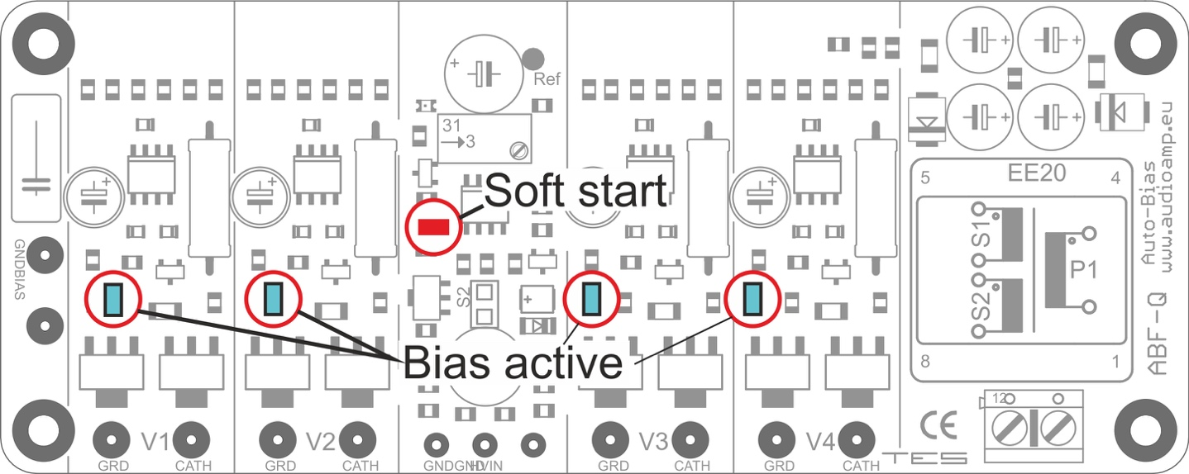

**If things do not work as they are supposed to:**

If the red LED on the ABF-Q module does not come on immediately after the amp is powered up, power it back down and check the 120VAC wiring to the AB-Qi module.

If none of the blue LED’s come on after the 40-50s soft start delay, power the amp back down. Check all your wiring from the AB-Qi module to your amp.

If say only three or two of the blue LED’s come on after the soft start delay, power the amp back down and check the wiring to that particular tube for which the blue LED did not go on for. Also check to make sure that the pins in that tube socket are nice and tight and that the tube fits into the socket not at all loose. Also check the pins in the tube socket of any oxidization, if they are dirty, perhaps use Deoxit or similar to clean the pins!

**Do’s and don’ts:**

Do check that the pins in each tube socket are tight and that each tube does not fit loosely in the socket.

Do check that the pins in each tube socket are clean of oxidization, use Deoxit or similar if they are not clean.

Good fitting and clean pins in tube sockets make ALL the difference!!

Don’t do a lot of tube rolling! This is a sure way to loosen up the pins in your sockets! If you cannot help yourself and you must do tube rolling, check the tightness of the pins each time you swap tubes!

**Optional REMOTE LED installation:**

**NOTE: carrying out this mod will void ANY and ALL warranties on the auto bias module, so you will do this at your OWN RISK!**

The AB-Qi circuit is designed as a general-purpose auto bias module to suit just about any tube based amplifier.

Only the shape of the AB-Q-ST70/ST120 pcb has been changed in order to fit the ST70/ST120 chassis.

The blue BIAS OK status LED’s are surface mounted on to the AB module pcb, this reflects the ‘general purpose’ design philosophy of the AB module.

This however means, that once the chassis bottom cover has been re installed, these blue BIAS status LED’s are no longer visible.

To make it easier to keep an eye on those status LED’s, you can modify the AB module to have ‘remote’ status LED’s. You can use either 3mm or 5mm standard LED’s for this, any color will work.

For the ST70/ST120, remote LED’s can be installed in place of the front octal sockets, you’ll have to make up some kind of plate or similar, or some have drilled holes in the VTA driver pcb where the original bias trimmers were located, however, do this at your own risk!!

In order to do this, you must first remove the surface mount LED’s from the AB module. This can be done using a soldering iron and some solder. Heat up the SMD LED by adding a small amount of solder to it, which will then loosen it off the pcb and it can be discarded.

Here is a good YouTube video of this process, <https://www.google.com/search?client=safari&rls=en&q=removing+SMD+components&ie=UTF-8&oe=UTF-8#kpvalbx=_52ZyXYbqHq--0PEPoqCVgAc22>

Once all the SMD LED’s have been removed, use solder wick or a vacuum de soldering iron to remove the excess solder and you will expose the ‘through hole’ on each LED solder pad. This has been added so that 24gauge wire can be inserted for the remote LED.

Once you have decided on the location of the remote LED’s, you will need to run a pair of wires for each LED from the AB module to the LED. We recommend that you use 24gauge pre twisted multistrand wire, the type we use is available from Jameco, here is the link, <https://www.jameco.com/webapp/wcs/stores/servlet/ProductDisplay?catalogId=10001&freeText=173164&langId=-1&storeId=10001&productId=173164&krypto=N9Vn1io5hW0V02LRc8lYv%2BV0PM1tSsYv9Th8N3uFKNmcMLMULQy%2Fg0BH5Tq5GOWuTKql7TyOVIIigxML6rNULbGjbktdmVg6tqwEbIh24gI%3D&ddkey=https%3AStoreCatalogDrillDownView>

You MUST be very careful with regards to the polarity of an LED. A LED as a Cathode/-ve and Anode/+ve end. This polarity MUST be maintained for the remote LED as well, see image next page which shows which AB module pcb pad is the Cathode/-ve and which is the Anode/+ve.

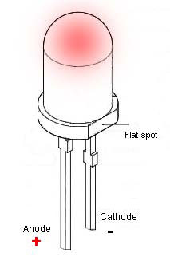

The terminals of the LED can be identified as follows

a) The shorter terminal is the Cathode/-ve

b) The flat spot also indicates the Cathode/-ve end

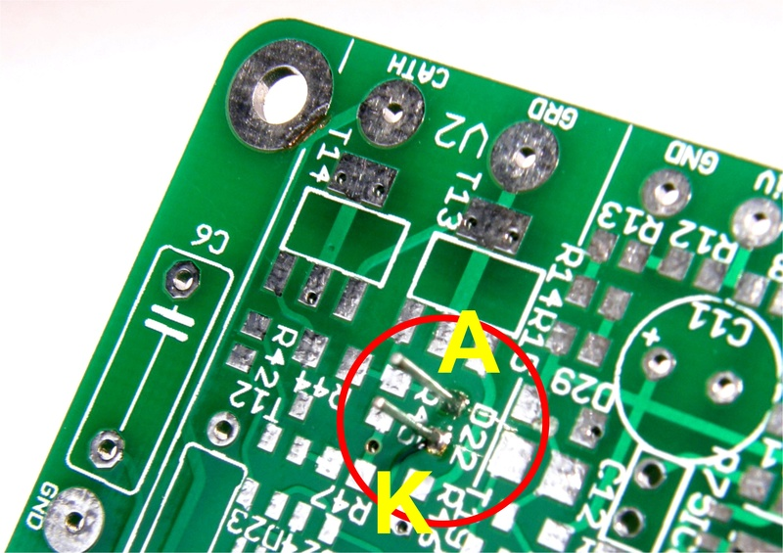

A = ANODE and K = Cathode

Following is a photo with remote 3mm green LED’s fitted to an AB-Q ST70/ST120 module pcb using the above mentioned 24gauge pre twisted wire. Here, the LED wires are wired in from the bottom of the AB module, but they can of course be mounted from the component side as well!

This photo will give you some idea anyway.

