AB_D

**Automatic bias control module for triode output stages or push-pull (PP) amplifiers**

Designed for **class A, AB, or B** amplifiers.

The module dynamically controls bias in **two tubes**.

The module dynamically controls automatic bias settings to maintain a strict symmetry of currents through both tube branches in the output stage, and to completely avoid flow of DC current through the output transformer, all with minimum requirements on anode current in the tubes. The DC saturates the output transformer which results in increased distortion of low-frequency sounds.

Bias control is realized by maintaining a constant bias on output tube grids, independently on the level of the driving signal.

The module may be supplied by the voltage for tube heating (6.3V or 12V AC) in the amplifier. However, this heating must not have a center tapped winding. An independent 6-12V AC power supply may also be used.

User manual:

**Automatic dynamic bias control module for two AB-D tubes**

**Benefits:**

* No need to constantly re-adjust tube operating points
* Significantly extended tube life
* Current regulation not influenced by music signal
* Clear undistorted sound for a great listening experience
* Significant increase in signal clarity – extreme reduction of hum and noise level of the amplifier
* Improved bass transmission
* No maintenance or additional setup needed
* Optimum utilization of tube life
* Suitable for all types of output transformers (namely toroidal ones which require automatic control)
* Safe operation due to minimized danger of runaway tube current – even when the amplifier is left unattended
* Universal use: suitable for all connection types
* Fully analogous control: the module has no digital elements

The modules are suitable for all amplifier types (classes A, AB, or B), as well as single-acting amplifiers with A-class tubes connected in parallel.

Their use is strongly recommended in existing amplifiers with fixed bias of output tube control grids, as aging of the tubes causes the need for a constant re-adjustment of their operating points.

The connection secures an absolute symmetry of anode currents through both branches of primary winding of the output transformer. This way, saturation of the the output transformer core with DC current with subsequent signal distortion and dearease in available power is reliably avoided.

Furthermore, tube operating points need no additional re-adjustments. The module constantly creates optimum conditions for the output stage, independently of tube aging and consequent changes in their parameters.

**Setting the quiescent current through the tubes**

The module is not connected in the amplifier. Apply the AC voltage taken from the filament supply of the tubes to 6.3…12.6V terminals. Wait for the green LED (indicating the ramp up of the reference voltage) to light up. P2 trimmer is used to set the reference voltage which determines the quiescent current through the tubes. S2 jumper is connected.

Use the following formula: Vref = 0.6V, then Io = 0.6/10 = 0.06 = 60mA per tube. Vref is measured between the “Ref” point and the ground. See the figure:

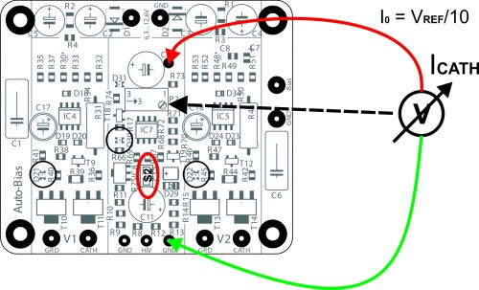

As a rule, S2 jumper on the module serves to connect the local source for generating the reference voltage. If the reference voltage is to be taken from the anode supply voltage (in case of a delayed ramp up of the anode voltage, for instance), apply this voltage to HiV and disconnect the S2 jumper.

**Connection of the bias source**

Use the bias supplied by the source in the amplifier. If the bias source is not a part of the amplifier, it has to be added, or the ABS-Q module has to be used (this model is equipped with the bias source).

The required minimum voltage of the bias source in the amplifier must be at least -10V higher than the required bias of output tubes.

**Connecting the module to the output stage circuits of the amplifier**

This example uses an amplifier with EL34 tubes connected in class AB with a mains voltage of 500V.

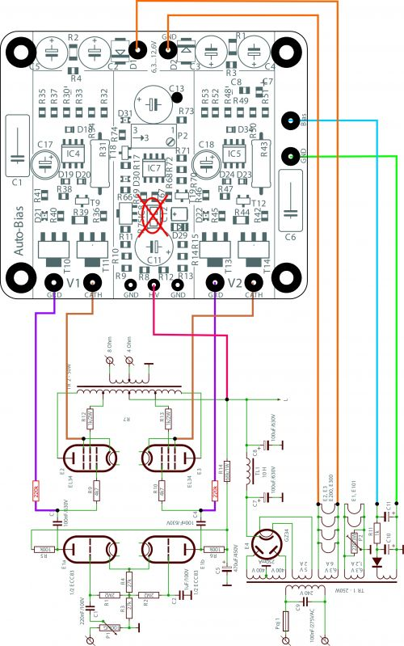

The circuits of the first grids of the output tubes must be equipped with isolation resistors (marked red with the value 100-220k).

**LED indication**

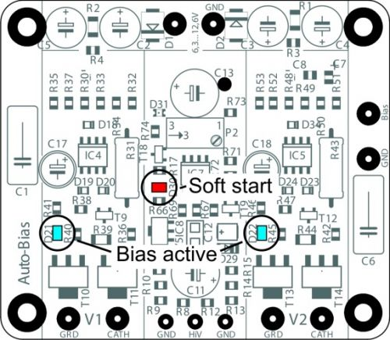

After the module has been connected and the AC supply voltage of 6.3 …12.6V applied, the “Soft Start” function will be initiated. The red LED located in the reference part of the module (Soft start) will be on for about 20s.

After this time, the LED will go off. The operational amplifiers of the automatic system will start to simultaneously sample the voltage of cathode resistors and set the bias for the grid bias. This process is indicated by blue LEDs (bias active).

Depending on the voltage supplied by the local source of grid bias in the amplifier, the values will stabilize after some time and the tube bias will be permanently set to unify all flows through all the four tubes. This way, saturation of the the output transformer core with DC current will be reliably avoided with minimum requirements on anode current in the tubes.